1. How does the application authenticate users
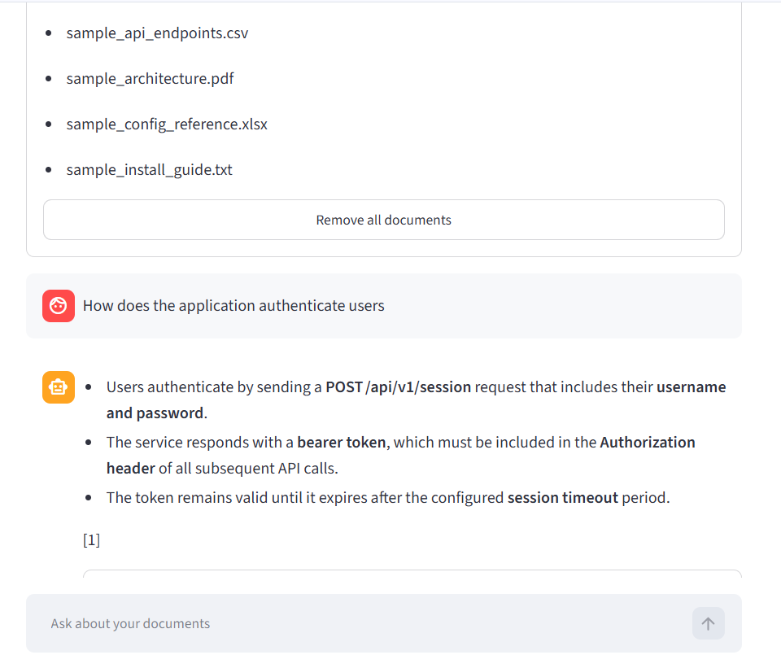

2. How is the service deployed and scaled in production? 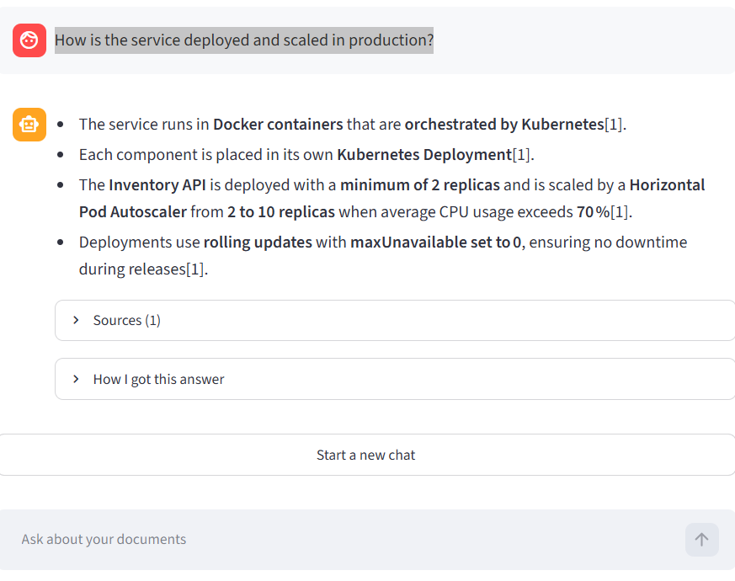

3. What should I check if the service fails to start?
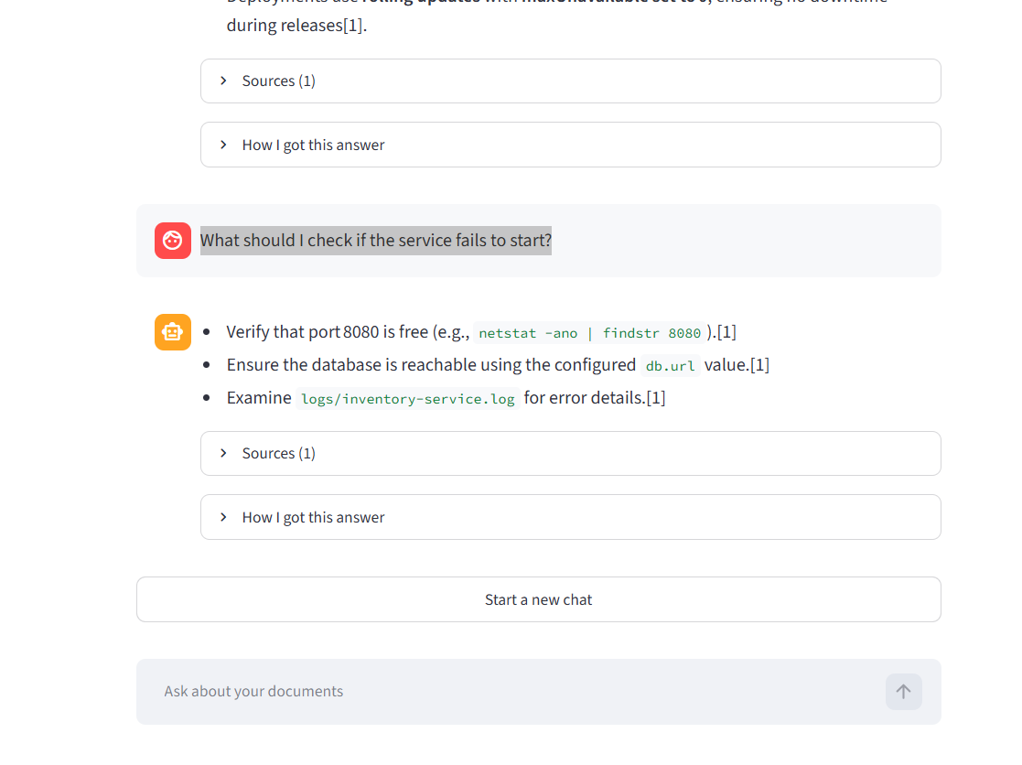

4. Which API endpoint returns the list of products?


